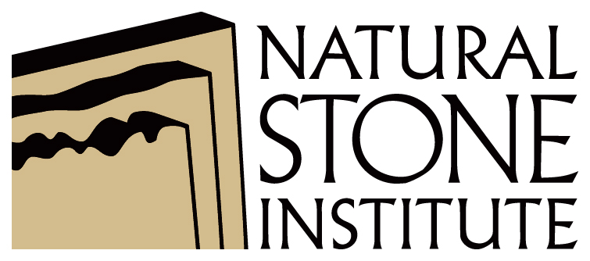 | Your company name  Workplace Safety Assessment  Job Hazard Analysis (JHA) |  |  |  | Your logo here
Document Control #: | Stone-JHA-003 |  |  | Revision Date: | mm/dd/yyyy
Document Title: | Job Hazard Analysis (JHA) |  |  | Issue #: | 1.0
Department: | Warehousing |  |  | Frequency: | Annually
Personal Protective Equipment Required: | Safety glasses, face shield, safety vest and hearing protection (some companies may add dust mask) |  |  | Completed by: | Name of Company Representative Here
Using a Wet Saw
Task Description |  | Hazard | Control
Operating Saw |  | Electrocution | - Connect saw to a Ground Fault Circuit Interrupter (GFCI) outlet  - Do not use extension cords without a grounding wire  - Drape the electrical cord down so that it dips below the level of the electrical outlet. This is often called a drip loop
Cutting Tile |  | Noise | - Properly wear hearing protection (ear muffs or plugs)
 |  | Kick Back | - Ensure blade is sharp  - Do not force cut  - Allow the saw to reach full power before starting to cut  - Properly wear safety glasses with face shield
 |  | Loose Clothing / Jewelry / Hair | - Do not wear bagging clothing when operating a wet saw  - Remove jewelry prior to operating the wet saw  - Pull hair back and secure
Binding Blade |  | Blade Breakage | - This is an indication that the blade may be dull, operator is forcing the cut or pressure is being applied to blade as cut is made. Stop work and evaluate where pressure is coming from.
Rationale or Comment:
  - Set the depth of the blade while the saw is unplugged and lock it at a depth so that the lowest tooth does not extend more than about 0.3 cm or 1/8" beneath the tile.
  - Keep all cords clear of cutting area.

End of Document

Disclaimer
This document is written as a general guideline. Natural Stone Institute and its Member companies have neither liability nor can they be responsible to any person or entity for any misunderstanding, misuses, or misapplication that would cause loss or damage of any kind, including loss of rights, material, or personal injury, or alleged to be caused directly or indirectly by the information contained in this document.

