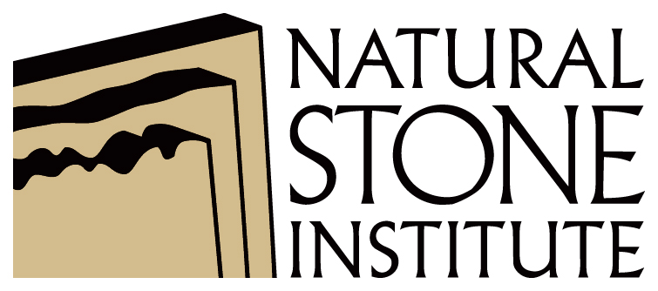 | Your company name  Workplace Safety Assessment  Job Hazard Analysis (JHA) |  |  |  | Your logo here
Document Control #: | Stone-JHA-004 |  |  | Revision Date: | mm/dd/yyyy
Document Title: | Job Hazard Analysis (JHA) |  |  | Issue #: | 1.0
Department: | Warehousing |  |  | Frequency: | Annually
Personal Protective Equipment Required: | Safety glasses, face shield, hearing protection (dust mask – see company requirements) |  |  | Completed by: | Insert Company Representative Here
Using a Circular/Table Saw
Task Description |  | Hazard | Control
Cutting Wood |  | Noise | - Wear hearing protection (ear muffs or plugs)
 |  | Kick Back | - Ensure blade is sharp  - Do not force cut  - Allow the saw to reach full power before starting to cut  - Wear safety glasses with face shield
 |  | Cuts to Operator | - Use two hands to operate saws - one on a trigger switch and the other on a front knob handle  - Do not carry the saw with a finger on the trigger switch
Loss of Control |  | Operator Injury / Product Damage | - Maintain a two hand grip and apply controlled pressure
Binding Blade |  | Blade Breakage | - This is an indication that the blade may be dull, operator is forcing the cut or pressure is being applied to blade as cut is made. Stop work and evaluate where pressure is coming from, ensure material is properly secured

Rationale or Comment:
  - Set the depth of the blade, while the saw is unplugged, and lock it at a depth so that the lowest tooth does not extend more than about 0.3 cm or 1/8" beneath the wood.
  - Keep all cords clear of cutting area.
  - Circular saws are designed for right-hand operation; left-handed operation will demand more care to operate safely.
  - If being used near a wet location, connect to a Ground Fault Circuit Interrupter (GFCI) outlet.

End of Document

Disclaimer
This document is written as a general guideline. Natural Stone Institute and its Member companies have neither liability nor can they be responsible to any person or entity for any misunderstanding, misuses, or misapplication that would cause loss or damage of any kind, including loss of rights, material, or personal injury, or alleged to be caused directly or indirectly by the information contained in this document.

