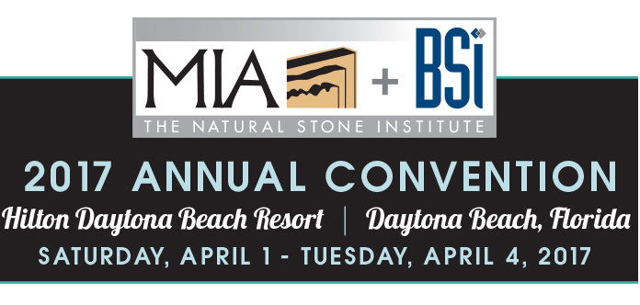

Convention Activity Sponsors
Coldspring
Connecticut Stone Supplies
Diamant Boart
Diatool Machines
Halbert Mill
Halquist Stone
Miles Supply
Northern Stone Supply
Park Industries
Polycor
Rolling Rock

Auction Item Donors
Artistic Tile - $1000 Artistic Tile Gift Certificate
Continental Cut Stone - 200 cu. ft. Cream Quarry Blocks
Continental Cut Stone - 200 cu. ft. Lueders Quarry Blocks
Delta Stone Products – 3 Night Park City Area/Mountain Home Getaway w/Choice of Activity
Diamant Boart - $500 Gift Certificate for Stone Fabricating Tools
Eurostone Machine USA - Drone w/Camera
Groves Inc. - Heavy Duty Stone Transport Rack
Indiana Quarries & Carvers – Carved Indiana Limestone Finials
Kohler Company - Moxie Showerhead w/Wireless Speaker
Laticrete International - Latapoxy 310 Stone Adhesive Package
Miles Supply - $500 Miles Supply Gift Certificate
Northern Stone Supply - 24 tons 3/4" - 1 1/4 Quartzite Flagging - any color
Ontra Stone Concepts - 2 Tickets to Saturday METS Game - Hyundai Club (buffet)
Rocky Mountain Stone - 3 Night/2 Day Fly Fishing Trip on the San Juan River (NM)
Sea Glass Fine Art - Choice of Limited Edition 12" Print
TexaCon Cut Stone - Indiana Limestone Fireplace Surround
TexaStone Quarries - 2 Tickets NASCAR Race @ Texas Motor Speedway

