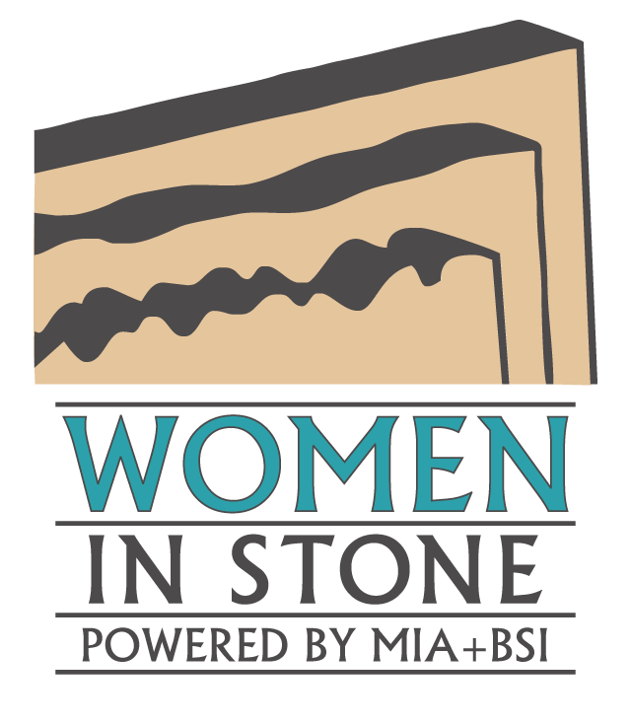
2018 Sub-Committee Application

MIA+BSI is regularly seeking stone industry professionals to serve on its Women in Stone Subcommittees. Applications are accepted throughout the year. Active participants in these Subcommittees will be given the opportunity to apply for a position on the Women in Stone Steering Committee in the following year.

Our Purpose:
Serve MIA+BSI's vision of being an essential partner in their members’ success.

Our Vision:
Provide resources and opportunities to recruit, retain, and advance women in the stone industry.

Our Mission:
• Expand on existing MIA+BSI educational offerings by developing topics specific to women's needs.
• Increase peer networking opportunities by coordinating venues to connect and learn.
• Develop a system of support and mentorship with other women in the industry.
• Create opportunities for women to serve on key industry committees.
• Recognize emerging & experienced women who excel in the industry.
• Create awareness of opportunities and career paths available to women considering careers in the stone industry.
• Work with the MIA+BSI Board of Directors and other MIA+BSI committees to achieve these goals.

Subcommittee Descriptions

Events: For all Women in Stone educational and networking events, the Events committee helps with the following: Plan agendas, coordinate speakers, and make decisions on audio/visual, food/beverage, and transportation. Women in Stone holds events regularly at TISE, Coverings, and the MIA+BSI Study Tour each year.

Communications: Curate content for the Women in Stone social media platforms including Facebook and Instagram. Plan promotions schedules for events and special projects including: email marketing, direct mail, and social media.

Recruitment: Create and implement strategies to increase membership in Women in Stone. Help new members get involved.

Special Projects: Define, organize, and develop special projects. Past projects have included the Wine & Stone CEU presentations, Empowerment Scholarship, Pioneer Award, and more.

Education: Plan content for Women in Stone educational events. Develop and maintain the Women in Stone Mentorship Program.

Qualifications

- Commitment – Demonstrated commitment to MIA+BSI and the natural stone industry. Committee members will be asked to commit a minimum of two hours per month towards this initiative.
- Experience – Relevant experience and interest in the subcommittee chosen is required. See descriptions for more information. Expertise and prior experience in leadership roles is not essential. These are entry level positions with opportunities for advancement within Women in Stone and adjacent industry initiatives.
- Eligibility – Any woman currently enrolled in Women in Stone.

Questions

If you are interested in serving, or know of potential committee members, please contact a member of the steering committee, MIA+BSI Administrator or Board Liaison. See contact list.

Interested candidates should also review the Women in Stone webpage at http://www.naturalstoneinstitute.org/womeninstone.

Steering Committee & Key Contacts

Kim Dumais
Miller Druck Specialty Contracting Co.
2016-17 Steering Committee Co-Chair
kim@millerdruck.com

Allyson Humphries
MS International
2016-17 Steering Committee Co-Chair
Allyson.H@msistone.com

Brie Pfannenbecker
Connecticut Stone
2014-15 Past Steering Committee Chair
brie@connecticutstone.com

Brenda Edwards
TexaStone Quarries
MIA Board of Directors WIS Liaison
Brenda@texastone.com

Sarah B Gregg
MIA+BSI
WIS Administrator
sarah@naturalstoneinstitute.org

Jennifer Sayles
Texastone Quarries
432-354-2569

Kathy Spanier
Coldspring
kspanier@coldspring.com

Amie Gilmore
Informa
Amie.gilmore@informa.com

Marcella Prado
Laticrete
mprado@laticrete.com

Katie Hatfield
CDC
khatfield@cdc-usa.com

Jacqueline Tabbah
International Stoneworks
jjtabbah@intlstoneworks.com

2018 Subcommittee Application

CONTACT INFORMATION:
Name: _______________________________________________________
Title: _______________________________________________________
Company: _______________________________________________________
Address: _______________________________________________________
_______________________________________________________
City: _______________________________________________________
State/Province: ____________________ Zip/Postal Code_____________
Country: _______________________________________________________
Telephone: ______________________ Fax: ________________________
Email: _______________________________________________________
GENERAL INFORMATION:
_______ | Number of years employed at your current company.
_______ | Number of years you have worked in the natural stone industry.
_______ | Number of years your firm has been an MIA+BSI member.
Previous industry employer(s), if any:
_______________________________________________________
COMMITTEE SELECTION:
Which Women in Stone subcommittee are you interested in joining and why?
Events | Communications | Recruitment | Special Projects | Education
____________________________________________________________________
____________________________________________________________________
____________________________________________________________________
____________________________________________________________________

COMMITMENT (Check all that apply):
_______ | Yes, I understand that participation on monthly committee calls and volunteering to lead break-out projects based on committee need is required. Expect a minimum of 2 hours per month.
_______ | Yes, I also recognize the importance of member recruitment and retention and will network with industry peers to promote membership.

EXPERIENCE – provide some examples of your experiences (e.g. event planning, social media, mentoring, recruitment, etc.) that could be applied to the Women in Stone Initiative, particularly the subcommittee you have chosen to join:
____________________________________________________________________
____________________________________________________________________
____________________________________________________________________
____________________________________________________________________

STRATEGIC THINKING– Provide your vision about where the Women in Stone initiative should be in the next 2 years:
____________________________________________________________________
____________________________________________________________________
____________________________________________________________________
____________________________________________________________________

Additional information I’d like the nominating committee to know about me:
____________________________________________________________________
____________________________________________________________________
____________________________________________________________________
____________________________________________________________________

Optional: Include Resume, Work History and Letters of Support.

Submit this form to:
Women In Stone (Powered by MIA+BSI)
Email: sarah@naturalstoneinstitute.org
Fax: 440.744.9222

