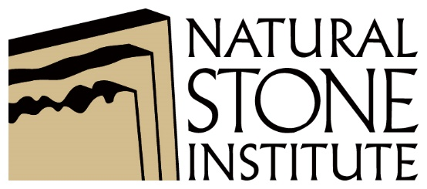

NATURAL STONE INSTITUTE AWARDS PROGRAMS
PHOTO RELEASE FORM

I hereby grant the Natural Stone Institute the absolute right and permission to reproduce the photographs that have been submitted to the Natural Stone Institute 2020 Pinnacle Awards program. This includes any Natural Stone Institute publication, associated websites (www.naturalstoneinstitute.org; www.usenaturalstone.com; www.buildingstonemagazine.com; www.bnpmedia.com) and any printed or electronic material produced by Natural Stone Institute to promote the current and future Awards events.

Submitted hard copy materials will not be returned. Natural Stone Institute will make every effort to properly credit photographer where appropriate. Photographer hereby waives the right to inspect or approve the aforementioned use of the photographs now or in the future.

Photographer hereby agrees to release and hold harmless Natural Stone Institute from any claims by the photographer for damages or liability arising from or related to the use of the photographs, including but not limited to any unintentional distortion, blurring, alteration, or optical illusion.

Photographer further warrants that the photograph(s) is original, not copied from any other work or material, and does not infringe on the copyright of any third party.

Project: _________________________________________________________________

Signature: _________________________________________ Date: _________________

Name: __________________________________________________________________

Photography Studio: _______________________________________________________

Street Address: ___________________________________________________________

City, State, Zip: ___________________________________________________________

Phone: ________________________ E-mail: ______________________________________

Please return form to:
Natural Stone Institute
FAX: (518) 803-4338 fax EMAIL: gina@naturalstoneinstitute.org

