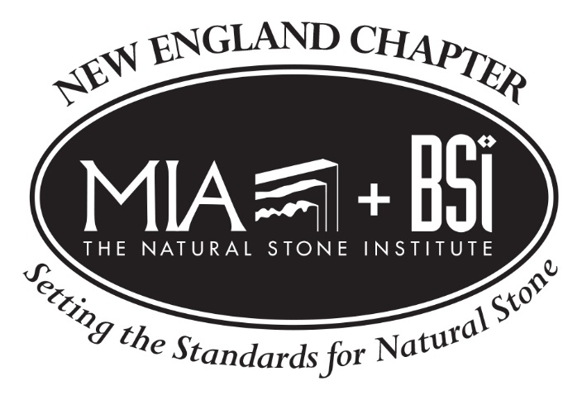
The Natural Stone Promotional Campaign
___________________________________________________________________
Date: Wednesday, May 3rd
Time: 6:00 to 8:00 pm
Speaker: Amy Oakley, Communications Manager, MIA+BSI
Location: Divine Stoneworks, 60 Pleasant St, Suite 6, Ashland, MA 01721
_______________________________________________________________________
MIA+BSI recently launched a campaign to promote the use of natural stone among homeowners, architects, and designers. During this session, attendees will learn about a new website, www.usenaturalstone.com, and get tips for repurposing content on the site for their own marketing efforts. Attendees will also learn how to contribute content for the site and gain widespread exposure for their work.

Learning Objectives:
- Learn about The Natural Stone Promotional Campaign and resources contained on the website, www.usenaturalstone.com.
- Discuss tips to effectively repurpose content from this website for your own marketing efforts.
- Review policies for submitting content to the website as a contributor.
- Learn how other companies have used the website to promote natural stone.
____________________________________________________________________________________
Registration Fees:
$25 Chapter Participant; $50 Non Chapter Participant; Complimentary for Architects and Designers
Register now at www.naturalstoneinstitute.org/NewEnglandMay3
Special Thanks to Our Host:  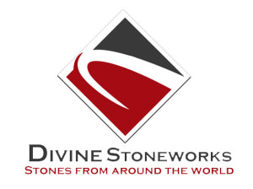 | Special Thanks to Our Sponsors:

